Date: October 16, 2017
In your journal record the following:
AP STUDIO ART ENTRY #17:
ART THINK : Look at the prints below: Which is your favorite? Why do you like it? How could you incorporate the successful elements of this print into your art work?
Announcements/Reminders:
- October 24 is the last day to turn in late work or re-dos for this term.
- Seniors remember to sign up for Portfolio Day ASAP – it opens to Juniors on Oct 20th.
Today’s Objective:
- Review
- Work on print project (transfer design and start to carve).
Homework: Work on 31 Nights

1.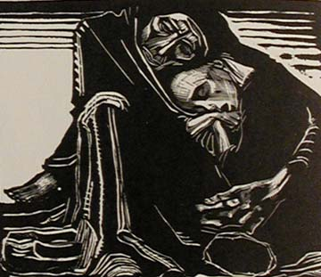 2.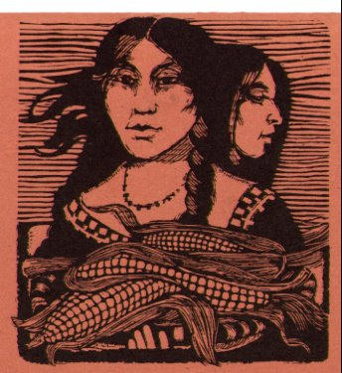 3. 4. 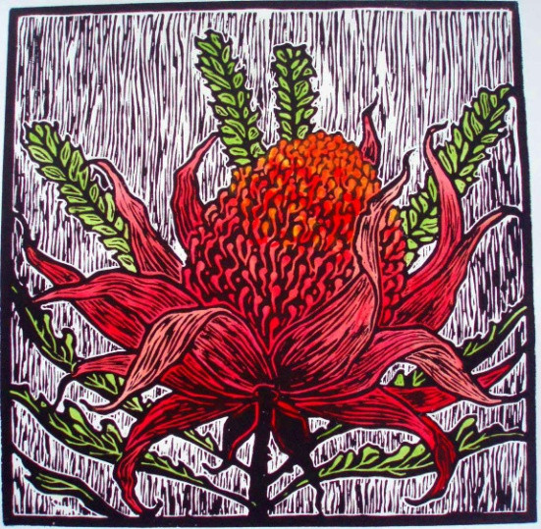 5.

