**Acrylic Self Portraits**

**Project Description:** Students will create a self portrait using IMPLIED TEXTURE and COLOR THEORY along with CONTOUR LINES. The painting will consist of two layers, bottom layer will be an acrylic textured background and the top transparency layer will be the portrait with contrasting color added.

[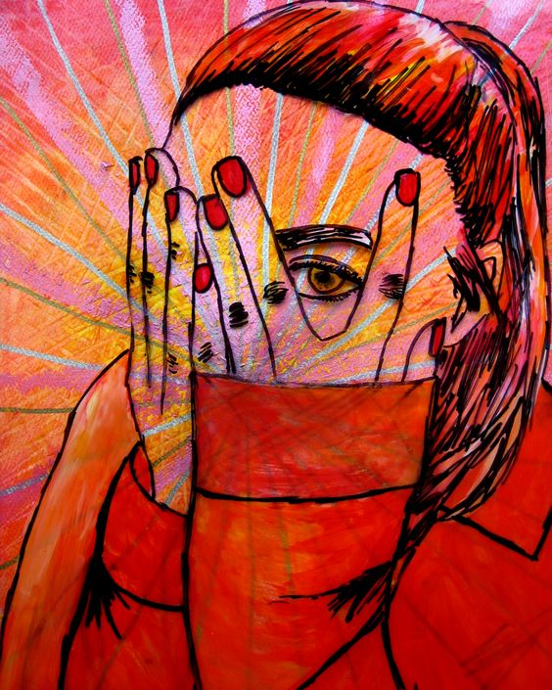](https://riversideschoolsart.weebly.com/uploads/5/3/6/1/53616693/33b5da003b4b2bae9dec7d11af057306_orig.jpg)

](https://riversideschoolsart.weebly.com/uploads/5/3/6/1/53616693/253ec267087264ccf93cf2728ebbbc98_orig.jpg)

](https://riversideschoolsart.weebly.com/uploads/5/3/6/1/53616693/286a40554280486968508353dafa01c3_orig.jpg)

](https://riversideschoolsart.weebly.com/uploads/5/3/6/1/53616693/760df5ed97e580c1c4b25d8db4d155c2_orig.jpg)

](https://riversideschoolsart.weebly.com/uploads/5/3/6/1/53616693/856deb564a996f5091a7bd162aea5f65_orig.jpg)

](https://riversideschoolsart.weebly.com/uploads/5/3/6/1/53616693/a89ea7b54ce35d51475b22258042adff_orig.jpg)

](https://riversideschoolsart.weebly.com/uploads/5/3/6/1/53616693/ac6da03e027f1ae9afa1f0822e79a770_orig.jpg)

](https://riversideschoolsart.weebly.com/uploads/5/3/6/1/53616693/d430b2497a4ed7189ffa8e1f4ef5de48_orig.jpg)

](https://riversideschoolsart.weebly.com/uploads/5/3/6/1/53616693/df7ad23bcdd04ff7897e4af06cb5e7c4_orig.jpg)

](https://riversideschoolsart.weebly.com/uploads/5/3/6/1/53616693/f132efb4f7ee5baf3ed6ac2c98cb2a42_orig.jpg)

](https://riversideschoolsart.weebly.com/uploads/5/3/6/1/53616693/ff44c3844ba9a70cd01f6a51b8f87e71_orig.jpg)